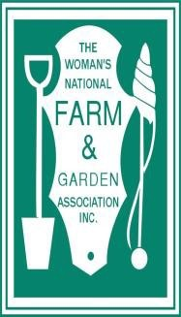
Contributions
Form

Woman’s National Farm & Garden Association, Inc.

Contributions:

Enclosed is my contribution of $

□ In loving memory of

□ In recognition of

□ To a specific award

□ For general use to WNF&GA

Please send announcement of my gift to:

Name: Address:
City:
State: Zip:

Sent by:

Name: Address: City:
State: Zip:
Contributions
Form

Woman’s National Farm & Garden Association, Inc.

Further Contributions:
Further contributions can be made to the following funds:
The Grace E. Frysinger Exchange $

The Scholarship Fund

The U.S. National Arboretum Fund $
$

Pennies for Friendship (ACWW) $

The Annual Meeting Angel Fund $

Payment:

Please make checks payable to WNF&GA and mail together with this form to:

Kathleen Welsh Beveridge
WNF&GA E&C Treasurer
1195 Dager Road
Warminster, PA 18974

kathy@sparknpc.com

1/15

